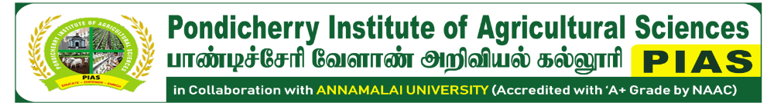
No: 82, Lalitha Nagar, Thavalakuppam, Puducherry – 605 007
📞 9442927204 / 9629026290 🌐 www.pias.org.in ✉ piasagri.cead@gmail.com

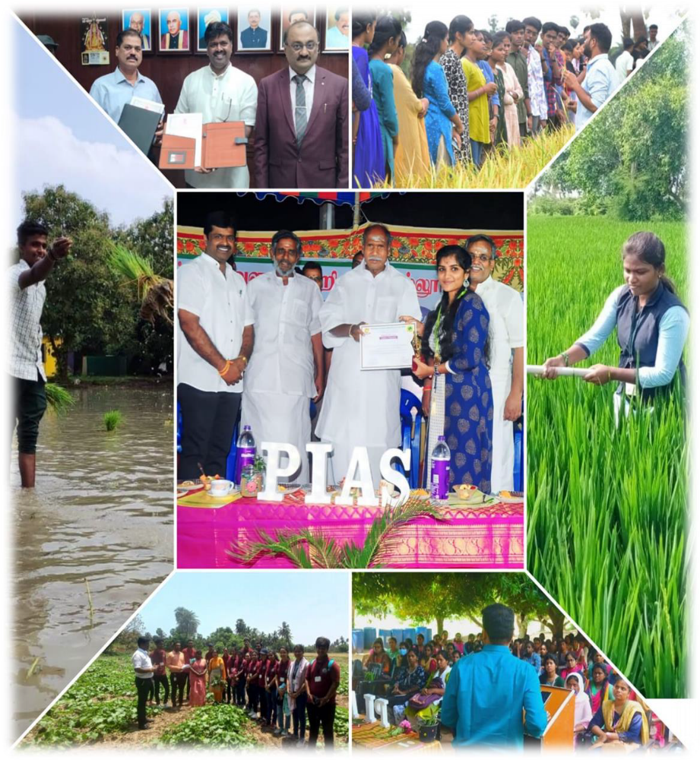
ANNUAL REPORT
2022-2023
From the Chairman’s Desk – Annual Report 2022–2023
It gives me immense pleasure to present the annual report for the academic year 2022–2023. This year marked a period of consolidation and community building for PIAS. We focused on strengthening our diploma programmes in Agriculture and Horticulture through farm-based learning, exposure visits, and improved teaching infrastructure.
Our students actively engaged in practical training, vermicomposting, and nursery management practices, while our faculty led several awareness initiatives on sustainable farming and compost technologies. The institution also launched its first pilot efforts in value-added production, including mushroom kits and herbal garden initiatives.
This year, we laid the foundation for a more inclusive academic environment by reaching out to students from underserved backgrounds and launching early discussions on expanding our offerings into certificate and degree programs. I extend my heartfelt thanks to our teaching and non-teaching staff, collaborators, and the community for their support.
Let us move forward with renewed commitment to our core mission—Educate, Empower, and Enrich.
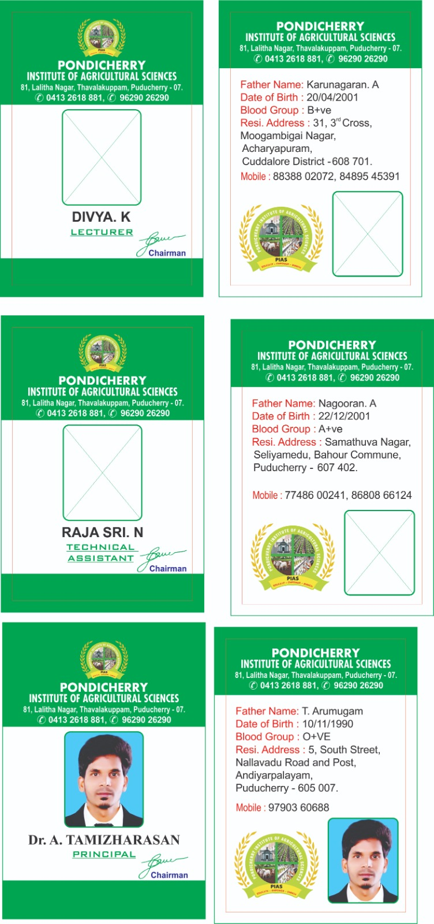
Mr. C. Ganeche

Chairman, PIAS

TABLE OF CONTENTS

- Introduction………………………………………………………………………… | 4
- Vision and Mission………………………………..………………………………... | 6
- Governance & Committees………………………………………………………… | 8
- Academic Programmes……………………………………....................................... | 13
- Curricular & Co-curricular Activities………………………………………………. | 17V
- Research Achievements…………………………………………………………….. | 23X
- Extension and Outreach Initiatives…………………………………………………. | 26
- Institutional Developments…………………………………………………………. | 29
- Collaborations and Industry Interface ……………………………………………... | 30
- Student Development Programmes………………………………………………… | 33
- Infrastructure Enhancements……………………………………………………….. | 36
- Way Forward……………………………………………………………………….. | 39

1. Introduction

Institutional Overview
The Pondicherry Institute of Agricultural Sciences (PIAS), established in 2017, stands as a pioneering institution in Puducherry, dedicated exclusively to offering Diploma programmes in Agriculture and Horticulture. With a steadfast commitment to advancing agricultural education, PIAS holds the distinction of being the first and only institute in the Union Territory to provide such diploma-level training. Since its inception, PIAS has evolved into a centre of academic excellence, catering to the educational and vocational aspirations of rural and semi-urban youth, particularly from Puducherry and neighbouring states. Strategically situated between the Pondicherry–Cuddalore state highway corridor, PIAS occupies a sprawling two-acre eco-conscious campus equipped with modern classrooms, fully functional laboratories, experimental farms, greenhouses, and a terrace garden. The institute’s central location and well-planned infrastructure ensure accessibility and optimal conditions for both classroom-based and hands-on field learning.
"PIAS operates under the visionary leadership of its Founder and Chairman, Mr. C. Ganeche, an accomplished agricultural professional holding a Master’s degree in Agriculture and a Ph.D. in Ecology and Environmental Sciences from Pondicherry University, Puducherry." His commitment to sustainable development is deeply rooted in his long-standing association with the Centre for Environment and Agricultural Development (CEAD)—a platform through which he has led various green and community-based agricultural initiatives across the Union Territory of Puducherry for over two decades. Mr. Ganache’s holistic approach to education and rural empowerment has significantly shaped the ethos and mission of PIAS. Affiliated with Annamalai University, one of India’s oldest and most respected institutions, PIAS benefits from a strong academic partnership. It has also been re-accredited with an ‘A+’ grade by the National Assessment and Accreditation Council (NAAC), reflecting its commitment to maintaining high standards in curriculum delivery, infrastructure, governance, and institutional values. This recognition highlights PIAS as a model institution known for its distinctive academic environment, value-driven pedagogy, and social responsibility.
The academic framework at PIAS is designed to provide a multidimensional learning experience. Students are exposed not only to theoretical knowledge but also to hands-on experiential learning through regular fieldwork, farm-based experiments, study tours, and industry interactions. The curriculum is enriched with certificate and value-added courses in areas such as mushroom cultivation, terrace gardening, herbal medicine, vermicomposting, and organic farming techniques. These initiatives equip students with practical skills aligned with current agricultural demands and green technologies. A core tenet of PIAS is its value-based education system, which emphasizes discipline, punctuality, and social responsibility. The institute maintains a supportive and nurturing environment that fosters emotional intelligence, leadership, and ethical behavior. Through a series of motivational talks, career guidance sessions, leadership development workshops, and personal counselling programs, students are empowered to face personal and professional challenges with confidence and clarity. Faculty members at PIAS are not just academic instructors but also mentors and guides who invest in the holistic development of every student.
PIAS promotes an inclusive and student-centric learning environment, encouraging participation in national and regional seminars, debates, workshops, and competitions. The students of PIAS have consistently earned accolades in intercollegiate events, demonstrating their readiness for future leadership roles in agriculture and allied sectors. Moreover, PIAS’s commitment to environmental sustainability is evident in its campus practices. From the establishment of herbal and Nakshatra gardens to azolla ponds, terrace gardens, and the plantation of traditional and high-value crops, the institute actively engages students in ecological farming models. These green practices not only enhance the biodiversity of the campus but also instil in students the principles of ecological stewardship and sustainable agriculture.
In conclusion, the Pondicherry Institute of Agricultural Sciences is more than just an educational institution; it is a transformative platform for young minds aspiring to make a meaningful impact in the fields of agriculture and environmental sustainability. Through a combination of academic rigor, practical training, value-based learning, and community engagement, PIAS continues to shape socially responsible, technically skilled, and environmentally conscious agricultural professionals.
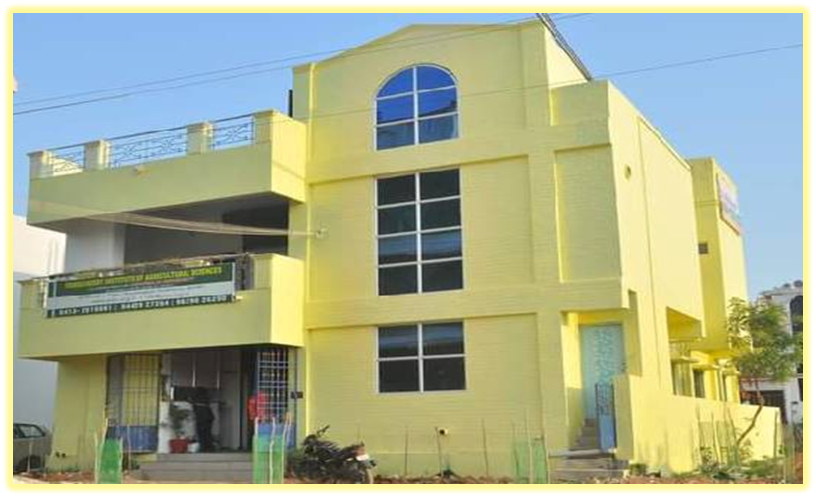
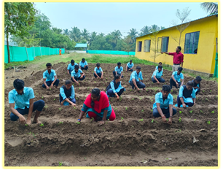
PIAS Campus & Farm

2. Vision and Mission
The Pondicherry Institute of Agricultural Sciences (PIAS) aspires to be a leading institution in agricultural education, research, and rural development. Our vision is to foster a vibrant learning ecosystem rooted in academic excellence, innovation, sustainability, and social responsibility. PIAS aims to nurture globally competent, environmentally conscious, and socially committed professionals who will lead the transformation of rural communities and tackle contemporary challenges such as food security, climate change, and ecological sustainability.
PIAS is dedicated to delivering transformative agricultural education that blends traditional wisdom with modern science and innovation. Our mission is aligned with India’s national priorities including Doubling Farmers' Income, Sustainable Development Goals (SDGs), and Climate-Smart Agriculture.
We are committed to:
- Providing practical and technology-driven education that integrates field-based learning with theoretical excellence.
- Developing multidisciplinary agricultural leaders equipped with global outlooks, entrepreneurial skills, and a strong scientific foundation.
- Instilling values such as truth, fairness, tolerance, cooperation, and environmental stewardship in every learner.
- Collaborating with rural communities, farmers, and NGOs to share knowledge, strengthen capacities, and promote inclusive agricultural development.
- Enhancing life skills, communication, and critical thinking, enabling students to succeed in careers, lead meaningful lives, and contribute to society at large.
Our mission is lived every day—through our classrooms, demonstration plots, field visits, community outreach, and research initiatives that collectively drive positive impact in agriculture.
The PIAS Insignia symbolizes the institute’s core motto:  “Educate, Empower, and Enrich”  It represents the values and aspirations of PIAS through the following key elements: | 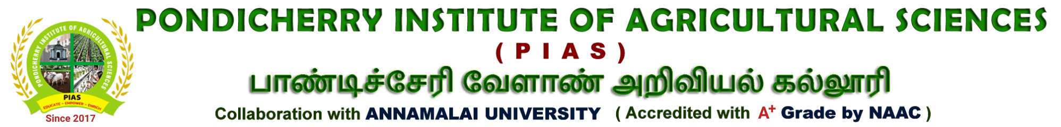
- Pondicherry Secretariat Emblem
Denotes our connection to the heritage and governance of the Union Territory of Puducherry, reflecting institutional pride and public service commitment.

- The Plant
Stands for agriculture, growth, and sustainability, symbolizing our academic focus on crop science and ecological farming.

- The Students
Represent the future of agriculture. Their presence in the emblem affirms our commitment to student-cantered learning and leadership development.
- The Cow
Symbolizes the allied agricultural sectors—particularly animal husbandry—which are essential for income diversification and integrated farming systems.
Together, these components reflect PIAS’s identity as a progressive, inclusive, and mission-driven institution, committed to shaping a greener, more resilient agricultural future.

3. Governance & Committees
The effective functioning of the Pondicherry Institute of Agricultural Sciences (PIAS) is supported by a structured governance framework involving a range of academic, administrative, and student welfare committees. These committees ensure transparency, quality, institutional development, and student-centric progress. Each committee is guided by dedicated staff members and works collaboratively to uphold academic excellence, research innovation, and campus safety.

3.1. Academic Governance Committees

3.1.1. Academic Planning & Curriculum Committee (APCC)
To review and enhance the academic curriculum in alignment with evolving trends in agricultural education and regulatory standards.
Responsibilities:
- Designing and updating course syllabus
- Scheduling academic calendars and timetables
- Introducing and monitoring value-added courses
- Assessing course outcomes and student feedback

In-charge:
- Convener: Mr. P. Manikandan
- Members: Mr. K. Tamilselvan, Ms. Deepika, Ms. Elakkiya priya

3.1.2. Board of Studies (BoS)
To approve academic programme structures and ensure curriculum relevance and quality.
Responsibilities:
- Finalizing course content and structure
- Ensuring compliance with Annamalai University guidelines
- Recommending instructional materials

In-charge:
- Chairperson: Mr. C. Ganache
- Faculty Representatives: Mr. P. Manikandan
- External Experts: Dr. K.R.Sundaravaradarajan, Professor and Head, Department of Agrl. Economics, Faculty of Agriculture, Annamalai University, Tamil Nadu, India

3.2. Administrative & Strategic Committees

3.2.1. Governing Body
To provide policy direction, strategic planning, and administrative oversight.
Responsibilities:
- Reviewing institutional development plans
- Approving budgets and infrastructure proposals
- Facilitating partnerships and MoUs

Chairperson: Mr. C. Ganeche
Members: Principal, External Academic Expert, Parent Representative

3.2.2. Institutional Development Committee
To oversee campus development, digital initiatives, and sustainability projects.
Responsibilities:
- Infrastructure expansion and maintenance
- Green campus projects (e.g., Crop cafeteria, Nutritional garden)
- Aesthetic and functional campus planning

In-charge:
- Coordinator: Mr. K. Tamilselvan
- Members: Mr. Mr. P. Manikandan, Farm Manager, Technical Assistant

3.3. Examination and Evaluation Committees

3.3.1. Examination Committee
To ensure smooth conduct of examinations in compliance with university regulations.
Responsibilities:
- Preparing schedules and managing logistics
- Securing question papers and coordinating with evaluators
- Conducting both internal and external assessments

In-charge:
- Chief Superintendent: Mr. P. Manikandan
- Coordinators:, Ms. Deepika, Ms. Elakkiya priya

3.3.2. Results Review & Moderation Committee
To ensure the accuracy, fairness, and timely release of examination results.

Responsibilities:
- Reviewing and finalizing marks
- Handling discrepancies and grievances
- Publishing provisional and final results

In-charge:
- Head of Evaluation: Mr. P. Manikandan
- Members: Course Coordinators and Department Representatives

3.4. Student Support and Welfare Committees

3.4.1. Anti-Ragging Committee
To ensure a safe, inclusive, and disciplined campus environment.
Responsibilities:
- Monitoring student behavior
- Conducting awareness and counselling programs
- Enforcing UGC anti-ragging guidelines

In-charge:
- Chairperson: Mrs. B. Sathya
- Student Welfare Officer: Mr. P. Manikandan
- Members: Class Mentors, Parent Representative

3.4.2. Student Grievance Redressal Committee
To address and resolve student concerns in an effective and impartial manner.
Responsibilities:
- Receiving and investigating complaints
- Ensuring timely redressal
- Promoting student welfare and satisfaction

In-charge:
- Convener: Mr. D. Sathyaraj
- Members: Mr. P. Manikandan, Mrs. B. Sathya

3.5. Skill Development and Career Services Committees

3.5.1. Placement & Career Guidance Cell
To prepare students for employment and link them with potential employers.

Responsibilities:
- Organizing campus interviews and industry visits
- Conducting career orientation and training
- Collaborating with agriculture-related firms and nurseries

In-charge:
- Coordinator: Mrs. B. Sathya
- Training Officers:, Ms. Deepika, Ms. Elakkiya priya

3.5.2. Internship and Industrial Training Committee
To coordinate practical training and field exposure for students.
Responsibilities:
- Arranging internships with agri-industries and research centres
- Supervising student performance during training
- Gathering feedback from host institutions

In-charge:
- Convener: Mr. P. Manikandan
- Field Coordinators: Ms. Deepika, Ms. Elakkiya priya

3.6. Co-curricular and Extension Committees

3.6.1. Cultural Committee
To promote student engagement through cultural and traditional events.
Responsibilities:
- Organizing festivals, annual day functions, and competitions
- Supporting participation in inter-collegiate cultural events

In-charge:
- Convenor: Mr. D. Sathyaraj
- Support Staff: Mr. P. Manikandan, Ms. Deepika

3.6.2. Extension and Community Outreach Committee
To build community relationships and provide agricultural training to stakeholders.
Responsibilities:
- Organizing farmer interaction programs
- Conducting school visits and demonstrations
- Promoting agro-tourism and training

In-charge:
- Coordinator: Mr. P. Manikandan
- Outreach Team: Ms. Jayasavitha.K, Ms. Monika

3.7. Research and Innovation Committees

3.7.1. Research Coordination Committee
To promote institutional research, innovation, and academic publication.
Responsibilities:
- Supporting research in sustainable agriculture
- Coordinating MoUs and collaborative projects
- Facilitating faculty and student research activities

In-charge:
- Chairperson: Mr. D. Sathyaraj
- Faculty Researchers: Mr. Manikandan Ms. Monika
- Research Assistants: Mr. Tamilselvan

4. Academic Programmes
The Pondicherry Institute of Agricultural Sciences (PIAS) is committed to offering high-quality, practical, and industry-relevant education in the disciplines of Agriculture and Horticulture. The academic programmes are designed to provide students with a solid theoretical foundation, hands-on training, and an ecologically responsible mindset. These programmes align with national agricultural priorities, sustainable farming practices, and the developmental needs of rural communities.

4.1. Diploma in Agriculture
This two-year full-time programme imparts essential knowledge in soil science, crop production, agronomy, organic farming, farm machinery, and agribusiness management. The curriculum is developed in accordance with Annamalai University’s academic guidelines, ensuring credibility and academic rigor.

4.2. Diploma in Horticulture
Focused on fruit and vegetable cultivation, nursery techniques, floriculture, landscaping, and post-harvest technology, this two-year diploma addresses the rising demand for skilled horticultural professionals and promotes entrepreneurship in horticulture-based industries.

4.3. Academic Affiliation
PIAS is affiliated with Annamalai University, a distinguished institution in agricultural education. This affiliation ensures that our academic content, evaluation procedures, and degree recognition meet the quality standards set by the University Grants Commission (UGC) and the National Assessment and Accreditation Council (NAAC).

4.4. Curriculum Structure
Both diploma programmes are structured over four semesters and include:
- Core theory courses
- Practical and laboratory components
- Fieldwork and project-based learning
- Value-added certification courses in:
  - Mushroom Production
  - Organic Farming
  - Vermicomposting
  - Terrace and Herbal Gardening
Assessment includes continuous internal evaluation (CIA), mid-semester tests, and final theory/practical examinations. The curriculum is outcome-oriented and prepares students for employment or higher studies.

4.5. Student Intake and Diversity
For the academic year 2022–2023, PIAS has an approved intake of 117 students:
- Diploma in Agriculture – 49 students
- Diploma in Horticulture – 68 students
Admissions are based on 12th standard marks, with priority given to students from rural and agricultural backgrounds. The institute embraces regional diversity, attracting students from Puducherry, Tamil Nadu, and neighboring states.

4.6. Innovative Pedagogy
PIAS integrates modern and practical teaching methods to enhance learning:
- Field-Based Learning: Daily farm exposure for real-time understanding of plant and soil sciences.
- ICT-Enabled Classrooms: Use of digital boards, audiovisuals, and e-learning tools.
- Exposure Visits: Organized study tours to research stations, agri-universities, and farms.
- Skill Training Modules: Mandatory training in vermicomposting, nursery techniques, and sustainable farming.
- Workshops & Self-Development Sessions: Including the “Public speaking” programme and leadership training to promote holistic growth.

4.7. Outcome-Based Learning
Student performance is evaluated through the OGPA system (Out of 10). Assessments include practical skills, project work, attendance, and participation in extension activities. The programmes aim to produce technically competent, career-ready, and socially responsible graduates.

4.8. Academic Ecosystem

Academic Almanac – 2022–2023
S.No | Particulars | Academic Year 2022-23
1. | Commencement of Semester | 23.04.2022
2. | First Year students Induction | 25.04.2022
3. | Commencement of classes | 27.04.2022
4. | Mid semester examination | 04.05.2022
5. | Practical examination | 08.06.2022
6. | Theory examination | 22.06.2022

S.No | Particulars | Academic Year 2022-23
1. | Commencement of Semester | 22.06.2022
2. | Commencement of classes | 24.06.2022
3. | Mid semester examination | 01.08.2022
4. | Practical examination | 07.09.2022
5. | Theory examination | 19.09.2022

4.9. Institutional Profile
- Registered Name: Pondicherry Institute of Agricultural Sciences (PIAS)
- Established: 2017
- Type: Co-educational
- Affiliation: Annamalai University
- Student Identity: PIASians
- Current Strength: 117 students (88 boys, 29girls)
PIAS is now recognized as a leading institution for diploma-level agricultural education in Puducherry. Its commitment to academic excellence, sustainable farming, and community development continues to empower aspiring agriculturists.

Faculty Profile
S. No. | Faculty Name |  | Designation
1 | Dr. Ragavan |  | Principal
2 | Mr. P. Manikandan |  | Lecturer
3 | Ms. Deepika |  | Lecturer
4 | Mr. Tamilselvan |  | Assistant professor
5 | Mr. Sathyaraj | Guest lecturer
6 | Mrs. B. Sathya | Admin

4.10. Institutional Committees
- Academic Committee
- Admission Committee
- Career Development Committee
- Examination Committee
- Anti-Ragging Committee
- Sports Committee
These committees play a crucial role in maintaining academic quality, discipline, student welfare, and extracurricular engagement.

4.11. Curricular Development Highlights
PIAS offers:
- Diploma in Agriculture
- Diploma in Horticulture
With additional value-added certifications in:
- Mushroom Production
- Azolla production
- Honey beekeeping
- Terrace and Herbal Gardening
- Vermicomposting
- Organic & Sustainable Agriculture
The curriculum is practical in orientation and includes farm-based projects, skill training, and field exposure, ensuring employability and real-world application.

4.12. Teaching, Learning & Evaluation
- Admission Criteria: 12th-grade performance, with preference for students from farming backgrounds.
- Diversity: Students come from a variety of socio-economic and regional backgrounds.
- Pedagogy: Emphasis on experiential learning, hands-on training, and tech-based instruction.
- Evaluation: Semester-based system using OGPA (out of 10) for transparent and consistent assessment.

4.13. Placement & Career Development
The Placement Cell conducts:
- Pre-placement training
- Industry interface sessions
- Campus interviews

4.14. Placement Highlights (2022–2023)
- Sri Krishna farm service, kumbakonam
- Sristi foundation
Several students also participated in internships and hands-on training programmes, enhancing their professional readiness.

4.15. Governance and Leadership
Under the guidance of Chairman Mr. C. Ganeche, PIAS emphasizes strategic growth, academic innovation, and community outreach. Monthly leadership review meetings are held to assess institutional progress and ensure excellence in all areas—from academics to infrastructure development and student success.

5. Curricular & Co-curricular Activities
At the Pondicherry Institute of Agricultural Sciences (PIAS), academic learning is deeply enriched through a wide range of curricular and co-curricular activities that emphasize hands-on experience, cultural identity, student engagement, and environmental consciousness. These activities are integrated into the academic calendar to enhance student learning, skill development, and social interaction.

5.1. Curricular Enrichment Activities
To supplement classroom-based teaching, PIAS organizes several field-based and experiential learning programmes designed to bridge theoretical knowledge with real-world agricultural practices:

5.1.1. Study Tours and Educational Visits
Students were taken on structured study tours to reputed institutions such as:
- J.K. coconut nursery at krishnagiri
- Regional research station at paiyur
- Protected cultivation unit at hosur
These visits provided students exposure to advanced crop research, farming models, and post-harvest technologies.
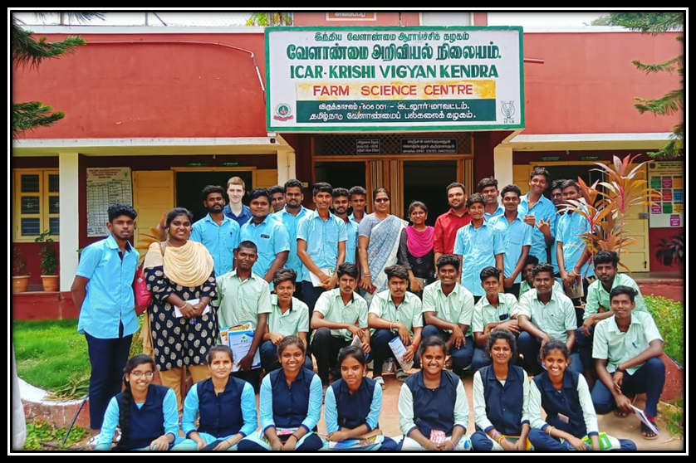
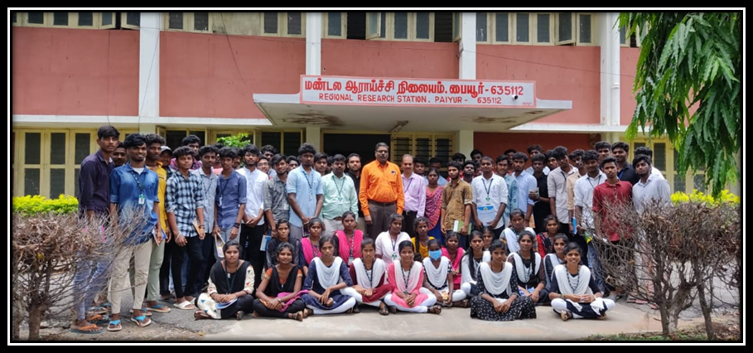
Study tour at research stations
5.1.2. Mechanized Paddy Transplanting
Students were trained in mechanical transplanting of paddy, allowing them to understand modern tools and machinery used in rice cultivation. This hands-on exercise introduced them to time-saving and labor-efficient farming methods.
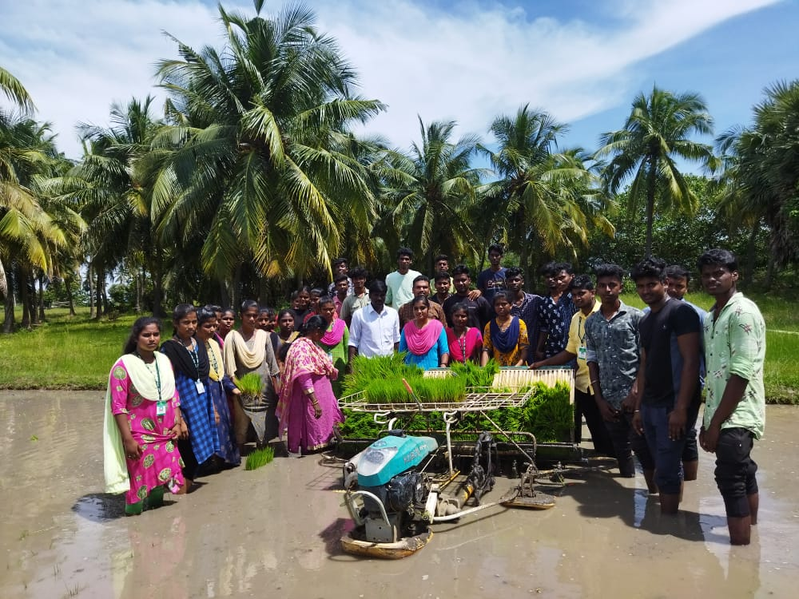
Students working in paddy field

5.2. Campus Green Initiatives & Practical Activities
As part of their experiential learning and practical coursework, students at PIAS enthusiastically participated in various on-campus cultivation and planting activities aimed at promoting sustainable agriculture, food security, and environmental awareness. These activities included:

5.2.1. Marigold Transplanting
Students engaged in the systematic transplanting of marigold seedlings, learning about spacing, pest management, and floral crop care—an important component in ornamental horticulture and pollinator support.
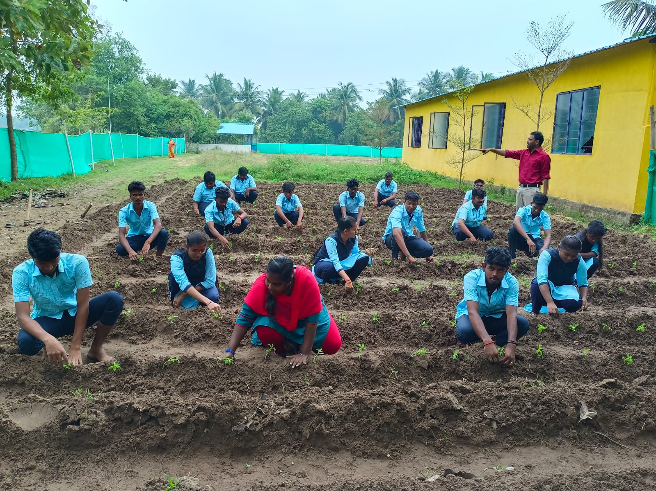
Marigold Trnsplating
5.2.2. Overview of Cucumber Field
As part of their vegetable science module, students maintained and monitored a dedicated cucumber field, observing crop growth, trellis management, and integrated nutrient application.

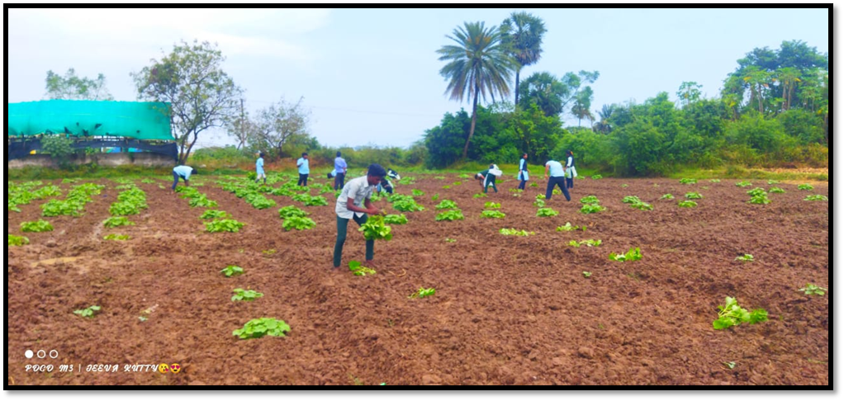
Cucumber field

5.2.3. Aadi Pattam Sowing (Traditional Rainy Season Crop Sowing)
Aligning with Tamil Nadu’s agro-climatic calendar, students practiced sowing techniques during the Aadi season, gaining insights into seed selection, broadcasting, and early-stage crop care.
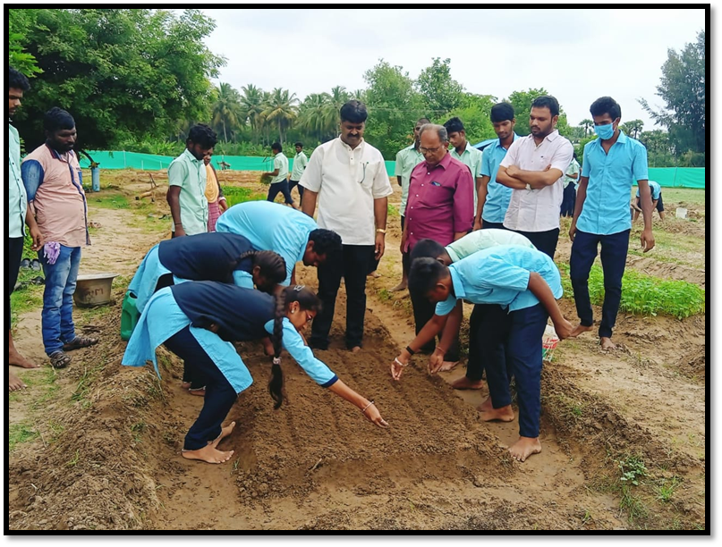
Aadi Pattam Sowing

These hands-on experiences are designed not only to enhance practical knowledge but also to foster a culture of urban farming, ecological responsibility, and agri-entrepreneurship among students. The green campus initiatives at PIAS serve as a living lab that connects theory with field realities.

5.3. Co-curricular Activities
At PIAS, co-curricular activities are carefully curated to promote cultural expression, community awareness, and leadership qualities among students.

5.3.1. Quiz and Competitions
In celebration of World Soil Day 2022, a quiz competition was conducted to promote awareness of soil conservation, fertility, and sustainable land use practices. Such academic events help foster a spirit of healthy competition and knowledge sharing among students.
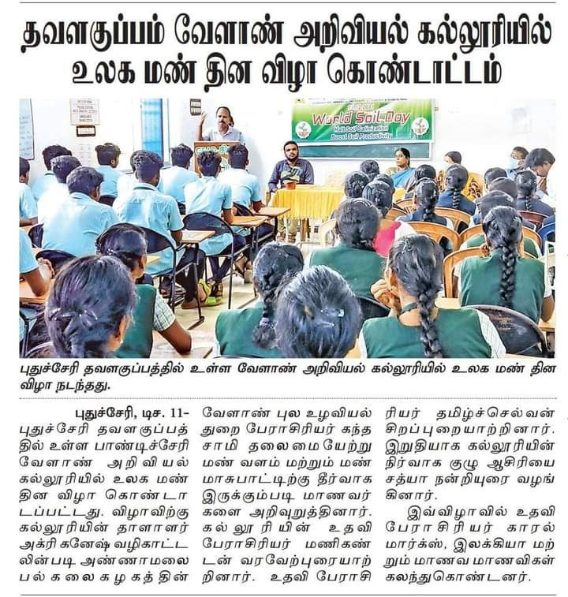
Farmers and soil Day Celebration

5.3.2. Tamil harvest festival (Pongal vizha celebration)
The traditional Tamil harvest festival, Pongal vizha, was joyfully celebrated on campus with cultural performances, traditional food preparation, rangoli art, and folk games. Students learned about the agricultural significance and cultural values of the event, fostering appreciation for local traditions.
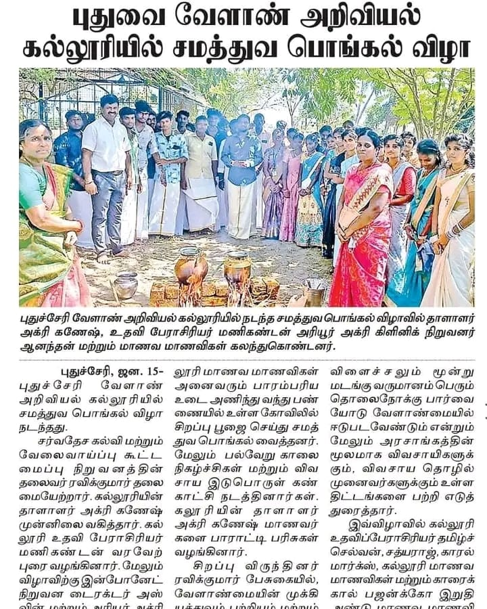
Tamil harvest festival
5.3.3. World Soil Day Observance at PIAS (05.12.2022)
In celebration of World Soil Day, PIAS organized a vibrant series of educational and awareness activities under the theme "Soil: Where Food Begins." The programme was designed to promote understanding of soil health, biodiversity, and sustainable agricultural practices among youth and the wider community.
Participation and Outreach
The event was attended by:
- Students from nearby schools and colleges in Puducherry and Tamil Nadu
- Diploma students of Agriculture and Horticulture at PIAS
- Faculty members, scientists, and guest speakers from allied institutions
Their involvement transformed the day into an inter-institutional learning exchange, strengthening awareness across educational levels.

Educational Activities Conducted
- Quiz Competitions: Students tested their knowledge on soil formation, fertility, natural farming inputs, and soil organisms.
- Audio-Visual Presentations: Short films and animated clips were shown to illustrate the effects of soil erosion, chemical overuse, and climate change on soil health.
- Model Displays and Posters: Students designed creative visual materials focusing on:
  - Soil Biodiversity and Microbes
  - Composting and Vermitechnology
  - Erosion Control and Water Retention
  - Traditional Soil Wisdom
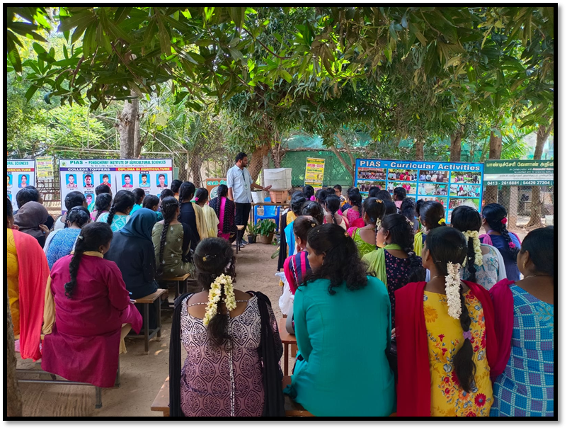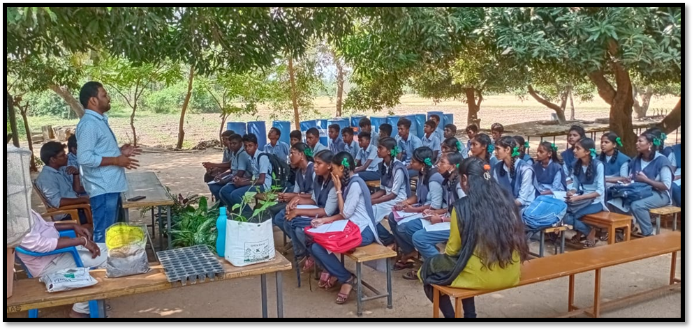

Participating School and College Students

5.3.4. Nakshatra Garden Tree Planting
Students participated in the tree planting activity under the Nakshatra Garden project, learning the link between indigenous species, biodiversity, and astrological beliefs in traditional agriculture.
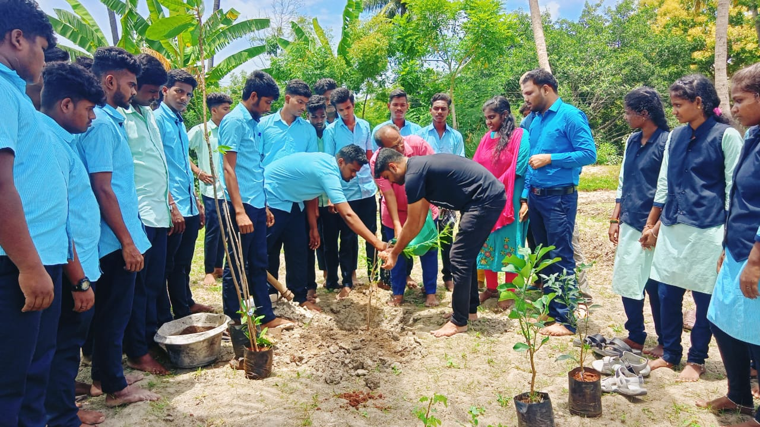

6. Research Achievements
The Pondicherry Institute of Agricultural Sciences (PIAS) places strong emphasis on practice-based, eco-sustainable research, focusing on challenges relevant to regional agriculture and national priorities. Our research efforts are led by committed faculty and actively involve student participation through field trials, pilot studies, and laboratory work, encouraging a research-oriented academic environment even at the diploma level.

6.1. Collaborative Research Platforms
Research at PIAS is supported and facilitated through institutional and external collaborations, notably:
- Centre for Environment and Agricultural Development (CEAD) – our in-house partner in sustainable agriculture research and green initiatives.
- Linkages with government departments, local NGOs, and nursery entrepreneurs for field demonstrations, data collection, and dissemination.
- Collaborative projects supported by Centre for Sustainability and Climate Studies, Department of Ecology and Environmental Sciences, Pondicherry University,

6.2. Key Research Themes and Ongoing Work

6.2.1. Organic Farming with Traditional Paddy Varieties
Faculty and students conducted field-based organic trials using native paddy varieties under organic nutrient management protocols. This project emphasized:
- Zero-chemical input systems
- Use of panchagavya, vermiwash, and botanical extracts
- Assessments of grain yield, disease resistance, and grain quality

6.2.2. Soil Health and Biogenic Soil Applications
PIAS has taken up field evaluations of biogenic soils—enriched with earthworm castings, organic matter, and beneficial microbes—for:
- Improving soil structure and porosity
- Enhancing microbial biomass and nutrient availability
- Promoting carbon sequestration and erosion resistance

6.2.3. Vermicomposting and Vermiwash Production
Multiple pilot-scale vermicomposting units were established on campus using leaf litter, cow dung, and local weeds. Outcomes include:
- Production of nutrient-rich compost
- Extraction and application of vermiwash as a foliar spray
- Biochemical analysis of nutrient profiles (NPK, micronutrients)
- Positive impacts recorded on okra plant growth and flowering

6.2.4. Microgreens Cultivation Trials
A recent initiative includes low-cost microgreens cultivation models, using recycled trays and organic media. Studies focus on:
- Nutritional profiling of species like mustard, fenugreek, and radish
- Growth comparisons under shade nets vs. open sun
- Market potential and consumer awareness

6.2.5. Biocontrol and Pest Management
As part of plant health management, students engaged in testing botanical biopesticides such as:
- Neem oil sprays
- Garlic and chili extract formulations
- Trichoderma and Pseudomonas fluorescens bioinoculants
The studies aimed to:
- Minimize use of synthetic pesticides
- Improve pest suppression in leafy vegetables and legumes

6.2.6. Salinity Tolerance Studies
Faculty-led trials using salinity gradients in controlled plots have begun to evaluate the tolerance capacity of select crop varieties (especially rice and groundnut). Parameters include:
- Germination rate
- Seedling vigor
- Ion accumulation (Na⁺, Cl⁻)

6.2.7. Medicinal Plant Cultivation & Evaluation
Under the Herbal Garden project, trials on medicinal plants such as Tulsi, Ashwagandha, and Aloe vera were conducted, studying:
- Growth response to organic inputs
- Pest resistance
- Market linkage with local ayurvedic outlets

Area of the research | No. of Trials/Studies | Lead Faculty/Coordinator
Organic Paddy Varieties | 3 | Mr. P. Mandikandan
Vermicomposting & Vermiwash | 4 | Mr. Tamiselvan
Biogenic Soil and Soil Fertility Studies | 2 | Mr. sathyaraj
Biocontrol Techniques & Plant Health | 3 | Ms. Deepika
Microgreens Cultivation | 1 | Ms. Elakkiya priya
Salinity Tolerance Experiments | 1 | Collaborative with CEAD
Medicinal Plants & Herbal Applications | 2 | Mr. P. Mandikandan
Impact and Student Engagement
These research activities:
- Enhance analytical thinking and technical skills among students
- Prepare learners for higher education and entrepreneurship
- Contribute to sustainable rural development models
- Encourage eco-friendly practices applicable to smallholder farming

6.3. Academic Exposure Visits
The year marked a significant leap in the research and collaborative outreach of PIAS. As part of our commitment to hands-on, field-based learning and inter-institutional collaboration, we welcomed internship students and visiting scholars from various institutions.
Notably, students from Maharashtra College and Bharathidasan Women's College, Puducherry visited PIAS for academic exposure and short-term research internships. These students actively engaged with our faculty, participated in laboratory and field demonstrations, and explored the latest trials being conducted at our campus.
During their internship, students were introduced to ongoing experimental modules
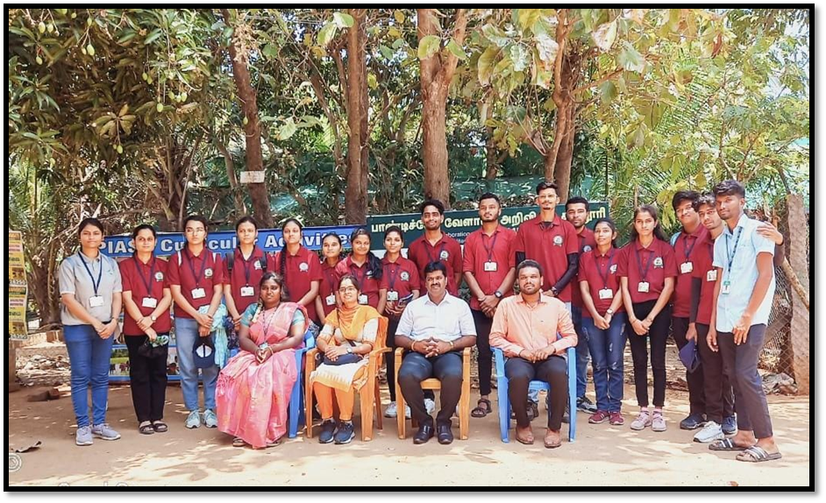
Students from Maharashtra College

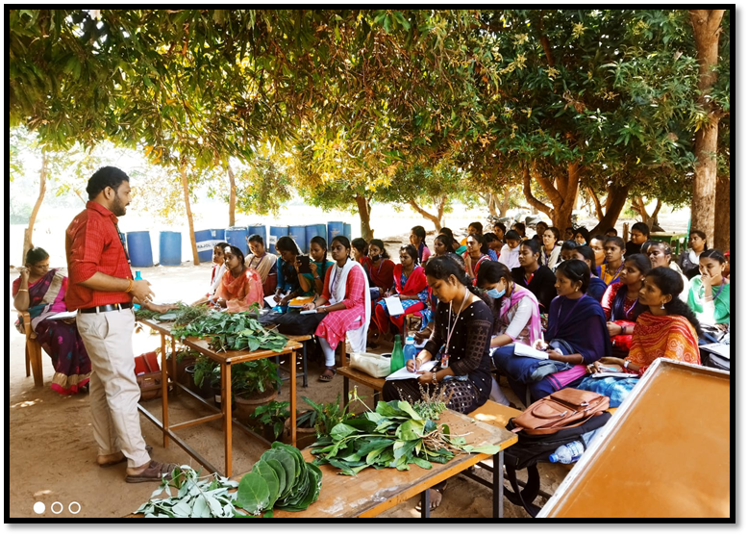

Students from Bharathidasan Women's College, Puducherry

7. Extension and Outreach Initiatives
The Pondicherry Institute of Agricultural Sciences (PIAS) strongly believes that agricultural education must extend beyond the classroom and into the fields and communities where it can have real impact. As part of our commitment to community engagement, rural development, and inclusive learning, PIAS undertakes a variety of extension and outreach initiatives that benefit both the student community and local farmers.
These activities are designed to:
- Facilitate two-way knowledge exchange between students and practicing farmers
- Equip students with communication, technical demonstration, and extension skills
- Promote sustainable agriculture at the grassroots level
- Support government missions related to soil health, organic farming, and climate-smart agriculture

7.1. Farmer Interaction Meetings
PIAS regularly conducts interactive sessions and workshops that bring together farmers, students, faculty, and technical experts to address field-level challenges and share best practices.

Key Highlights:
- A one-day “Farmer-Student Interaction” programme was held on 22.02.2023, focusing on:
  - Soil health management
  - Organic pest control methods
  - Water-saving techniques (drip and mulching)
- Farmers from nearby villages such as Thavalakuppam, Kirumampakkam, and Bahour actively participated.
- Demonstrations on vermicompost production, azolla cultivation, and biopesticide preparation were delivered by PIAS faculty and final-year students.
- Feedback sessions allowed farmers to express their practical constraints, which helped PIAS redesign extension modules for future events.
These meetings served as powerful tools for agricultural empowerment and community bonding, and also trained students in real-world extension methods.

7.2. Exposure Visits and Community Education
To help students and school children better understand the scope of agriculture, PIAS organized one-day exposure visits as part of its agro-education programme.

Activities Conducted:
- One-Day Agro-Tourism Programmes were organized for:
  - Dr. Ambedkar Government Higher Secondary School, Kirumampakkam
  - Achariya School, Puducherry (Montessori I & II students)

During the visits, students explored:
- Vermicomposting pits
- Herbal garden with labeled species
- Terrace gardening systems
- Mushroom production units
- Animal shed and azolla cultivation tanks
Faculty members conducted awareness talks on:
- Importance of organic food
- Conservation of local biodiversity
- Home-scale vegetable gardening
These programmes aim to plant early seeds of interest in agriculture among school children, and also give our students practical experience in demonstration-based teaching.

7.3. Green Campus and Demonstration Units
PIAS has developed multiple on-campus live demonstration units to train both students and farmers in cost-effective, replicable agricultural practices.

Key Initiatives:
- Azolla Pond Development:
  - Created by first-year students using recycled cement tanks
  - Demonstrated as a protein-rich livestock feed for cattle and poultry
  - Training modules delivered to visiting farmers and SHGs
- Guava Orchard Establishment:
  - Over 40 guava saplings were planted with the help of students in the orchard zone
  - Topics taught: pruning techniques, pest scouting, irrigation management
- Coconut Plantation:
  - 118 coconut seedlings were planted along the farm perimeter
  - Students learned about spacing, pit preparation, and basal nutrient application
  - This long-term project promotes agroforestry integration on campus
These practices are not only educational models but also contribute to campus sustainability and livelihood-oriented learning.

7.4. Thematic Awareness Days and Community Engagement
As part of our extension commitment, PIAS observes internationally significant agricultural and environmental days with active involvement from students and village stakeholders.

World Soil Day 2022:
- Celebrated on 05.12.2022
- Activities included:
  - Student quiz competition
  - Audio-visual awareness sessions
  - Farmer lectures on soil organic matter and erosion prevention
  - Display of student-prepared charts and working models on vermicompost bins, cover cropping, and soil microorganisms

7.5. Additional Awareness Events
- Medical Camp on World Hypertension Day (05.05.2023)
  - Organized jointly with MGMCRI, benefiting both PIAS staff and local farmers
- Demonstration of Biocontrol Methods
  - Training on the preparation and application of neem extract, cow urine spray, and panchagavya
- “Incense Stick Production” Workshop (26.09.2023)
  - Held for women self-help groups using waste temple flowers
These outreach activities provide relevant, low-cost technologies to farming communities while making students more socially conscious and practically skilled.

8. Institutional Developments
The Pondicherry Institute of Agricultural Sciences (PIAS) has made significant strides in its physical infrastructure, digital presence, and campus aesthetics during the academic year 2022–2023. These developments are aligned with the institute’s mission to offer a modern, student-friendly, and environmentally enriched learning environment that supports both academic and non-academic growth.
Institutional improvements were planned and executed under the strategic guidance of Chairman Mr. C. Ganeche, with active involvement from faculty members, non-teaching staff, and students. The goal of these initiatives is not only to enhance functionality and visibility but also to foster a campus atmosphere that promotes learning, biodiversity, and community engagement.

8.1. Campus Landscaping and Name Board Placement
To improve aesthetic appeal and navigation, extensive landscaping and installation of signage were undertaken across the campus.

Key Improvements:
- Landscaping near the mushroom shed, entrance gate, and mess area
  - Use of decorative and flowering plants
  - Addition of seating benches and shaded corners
  - Soil levelling, mulching, and ornamental grass beds
- Tree planting along pathways and orchard borders, including coconut, neem, and guava
- Erection of directional and informational name boards:
  - Clearly marked signs for classrooms, laboratories, herbal garden, farm zones
  - Durable, weather-resistant materials used for signage
  - Multilingual labels to support both local and outstation visitors
These improvements reflect PIAS’s focus on eco-campus development, functional design, and branding clarity.

8.2. Impact of Institutional Developments
Collectively, these developments have contributed to:
- Enhanced campus branding and identity
- A more welcoming and organized physical environment for students and visitors
- Improved opportunities for practical learning in digital literacy, plant biodiversity, and eco-aesthetics
- Support for green certification and NAAC quality indicators related to infrastructure and digital outreach

9. Collaborations and Industry Interface
At the Pondicherry Institute of Agricultural Sciences (PIAS), industry engagement and academic collaboration are central to our vision of delivering career-ready, skill-based agricultural education. Recognizing the evolving needs of the agricultural sector, PIAS actively cultivates partnerships with research institutions, universities, industries, nurseries, and technology developers to bridge the gap between curriculum and practice.
Through collaborative efforts, students and faculty are provided with access to state-of-the-art research, modern farming techniques, and employment opportunities. These engagements also support curriculum enhancement, internship development, extension activities, and real-time exposure to technological innovations.

9.1. Campus Recruitment and Industry Placements
One of the major highlights of the academic year was the successful on-campus interview and placement drive conducted by UCAL – Drone Manufacturing Company, Chennai. This opportunity was instrumental in connecting students to cutting-edge agricultural technology sectors such as drone-based precision farming, aerial spraying, and agri-tech support services.

UCAL Placement Highlights:
- Campus interview conducted in January 2023
- Final-year diploma students participated in pre-placement training sessions, mock interviews, and skill assessments
- Shortlisted candidates received offer letters with placements in Chennai and surrounding regions
- Training support offered by faculty members from the Career Development Committee
This event marked a major step toward establishing PIAS as a talent hub for agriculture-related technologies and services, particularly in the domains of automation and digital agriculture.

9.2. Institutional Visits and Collaborations with Research Stations
To foster academic enhancement, PIAS has established strong academic relationships with national and regional agricultural research institutions. These collaborations aim to:
- Introduce students to research methodologies
- Provide access to demo farms and trial plots
- Facilitate joint workshops, extension activities, and internships

9.3. Key Institutional Collaborations

9.3.1. National Research Centre for Banana (NRCB), Trichy
- Students visited field trials on high-yield banana varieties, tissue culture labs, and post-harvest storage facilities
- Faculty engaged in discussions on collaborative research themes, including banana-based value chains and disease management
- Possibilities for future student internships and joint certification courses discussed

9.3.2. Tamil Nadu Agricultural University (TNAU), Coimbatore
- Engagement with faculty from Agronomy, Horticulture, and Agricultural Engineering departments
- Exposure to TNAU’s e-extension labs, soil testing centers, and research farms
- Discussions held on:
  - Sharing of curriculum innovations
  - Collaborative publications
  - Access to TNAU library and digital resources

9.3.4. Horticultural Research Station (HRS), Kodaikanal
- Study tour organized for second-year horticulture students in November 2023
- Sessions covered protected cultivation, cold-weather fruit crops, and ornamental plant breeding
- Introduction to clonal propagation and floral biotechnology techniques
- Informal MoU under review for faculty development and short-term training exchange

9.4. Additional Industry and Nursery Linkages
Beyond formal research institutions, PIAS has built working relationships with commercial farms, nurseries, and agri-service firms. These field partnerships allow students to observe enterprise models, develop entrepreneurial insights, and gain practical knowledge in:
- Nursery management
- Propagation techniques
- Organic input preparation
- Harvesting, packing, and marketing operations
Key partners include:
- Santhi Clonal Nursery, Vegakollai – Known for banana and guava saplings
- Private agri-input dealers for live demo sessions on biofertilizers and micronutrients
- Drone operators and agribusiness consultants for training modules on aerial mapping and data analysis

9.5. Benefits of Collaborations
The partnerships and outreach engagements have contributed to:
- Enhanced student confidence through real-world exposure
- Curriculum enrichment with insights from experts and ongoing projects
- Research opportunities in areas such as organic farming, biocontrol, and salinity tolerance
- Job creation and internships for graduating students
These industry-academic linkages directly support the institution’s mission of producing skilled, employable, and entrepreneurial agricultural professionals capable of thriving in both rural and corporate environments.

Table of Collaborations and Visits
Institution / Partner | Type of Collaboration | Focus Areas | Activities Conducted
UCAL, Chennai | Industry Placement | Drone Technology in Agriculture | Campus Interviews, Training, Job Offers
NRC Banana, Trichy | Research Collaboration | Tissue Culture, Banana Cultivation | Study Tour, Research Exposure
TNAU, Coimbatore | Academic Exchange | Agronomy, Soil Health, Organic Practices | Lab Visit, Curriculum Feedback, Workshop
HRS, Kodaikanal | Technical Visit & Informal MoU | Horticulture, Protected Cultivation | Field Training, Exposure Visit
Santhi Clonal Nursery, Vegakollai | Nursery Partnership | Sapling Propagation and Marketing | Internship, Field Demo

10. Student Development Programmes
At the Pondicherry Institute of Agricultural Sciences (PIAS), education is not limited to academic instruction—it extends into the personal growth, emotional well-being, and social development of every student. The institution strongly believes in nurturing students to become confident, compassionate, and capable individuals equipped to handle real-world challenges with clarity and resilience.
To achieve this, PIAS implements a variety of student development programmes, which include structured mentoring, value-based training sessions, self-awareness exercises, and material support initiatives. These programmes are aligned with the institution’s broader mission to provide value-based, holistic agricultural education.

10.1. “Who Am I?” – Self-Awareness and Identity Session
One of the most transformative programmes conducted at PIAS is the “Who Am I?” session, designed to help students explore their individual purpose, self-identity, strengths, and goals. This session is conducted annually for first-year students as part of their orientation programme and has received excellent feedback for its motivational and reflective value.

Session Objectives:
- Encourage students to reflect on their personal values and aspirations
- Help them identify strengths, weaknesses, and leadership potential
- Facilitate discussion on life purpose and the role of agriculture in society
- Create a safe space for sharing ideas, dreams, and concerns

Methodology:
- Ice-breaker activities and self-introduction rounds
- Guided introspection using structured worksheets
- Motivational talks by faculty and guest mentors
- Group sharing sessions to build mutual respect and empathy
Impact: Students reported a stronger sense of identity, improved self-confidence, and a more focused approach to learning and life planning after participating in the session.

10.2. Personal Counselling and Mentoring Support
PIAS recognizes that students come from diverse backgrounds, including many from rural, first-generation learner families. To support their emotional well-being, academic adjustment, and personal growth, the institute offers:

Personal Counselling Services:
- One-on-one counselling sessions led by faculty mentors and external professionals
- Support on issues related to academic pressure, peer relationships, stress, and goal setting
- Confidential and student-friendly process
- Focused support for students during exam stress periods

Group Mentoring:
- Faculty assigned as Class Mentors monitor academic and emotional progress
- Monthly interactive feedback sessions to discuss challenges and plan improvement
- Encouragement for peer mentoring and support circles
Outcome: The presence of a structured support system has significantly improved student engagement, class attendance, and interpersonal relationships on campus.

10.3. Leadership Workshops and Life Skills Training
To equip students with practical life skills, decision-making capabilities, and leadership qualities, the following workshops were conducted:

Key Activities:
- Leadership Skills Workshop: Focused on team dynamics, conflict resolution, and ethical leadership
- Communication and Public Speaking Sessions: To overcome hesitation and improve presentation skills
- Decision-Making and Time Management Modules: Real-life scenarios were used to teach time allocation, prioritization, and personal planning
Special guests from agri-business firms, local NGOs, and university alumni were invited to interact with students and share real-world challenges in the agriculture field.
These interventions have strengthened student confidence, encouraged initiative-taking, and prepared them to serve as ambassadors of sustainable agriculture in their communities.

10.4. Material Support: Uniform and Book Distribution
As part of its inclusive approach, PIAS provides essential academic materials and support to students, especially those from underprivileged backgrounds.

Support Offered:
- Uniform Distribution:
  - Each student receives two sets of uniforms designed for practical and classroom use
  - Promotes equality, discipline, and institutional identity on campus
- Book and Notebook Distribution:
  - Standard textbooks aligned with Annamalai University syllabus are provided
  - Practical notebooks and record books distributed semester-wise
  - Supplementary reading material on vermicomposting, mushroom cultivation, and value-added farming is also made available in the resource room
- Toolkits and Lab Essentials:
  - Selected students were provided with seed kits, pruning tools, and mini-lab items for use during field and lab sessions
Student Voices: The support has reduced the financial burden on families and helped maintain focus on studies without stress about academic expenses.

10.5. Holistic Growth and Outcome Focus
Through these student development programmes, PIAS ensures that every student:
- Gains self-awareness and clarity of goals
- Develops interpersonal and communication skills
- Learns to balance academic, emotional, and social responsibilities
- Is empowered to take leadership roles, both within and outside the institution
The institution’s approach recognizes that knowledge alone is not enough—character, confidence, and compassion are equally essential for success in today’s evolving agricultural landscape.

11. Infrastructure Enhancements
During the academic year 2022–2023, the Pondicherry Institute of Agricultural Sciences (PIAS) undertook several key infrastructure development projects aimed at enhancing the functionality, aesthetics, and eco-educational value of the campus. These upgrades support the institution’s goal of providing a green, student-friendly, and technically equipped environment that promotes experiential learning and sustainable practices.
Under the leadership of Chairman Mr. C. Ganeche, the infrastructure team collaborated with faculty, farm staff, and students to ensure that each development serves a pedagogical as well as practical purpose, contributing to both agricultural education and environmental enrichment.

11.1. Landscaping Around the Mushroom Shed
The mushroom production unit is one of the key practical training centers for PIAS students. To improve the ambience, accessibility, and instructional environment, a detailed landscaping project was undertaken around the mushroom shed.

Enhancements Made:
- Levelling and soil enrichment around the shed area to ensure smooth student movement during practical classes
- Plantation of shade-tolerant ornamental plants and medicinal shrubs along the pathway leading to the shed
- Installation of paving stones, boundary hedges, and drip irrigation for the plants
- Addition of a composting pit nearby to integrate waste from the mushroom shed for vermicomposting activities
These changes transformed the mushroom unit into a well-organized, eco-friendly, and student-engaging learning space, where theory and practice blend seamlessly.

11.2. Revamping the Farm Entrance and Access Zones
Recognizing the importance of first impressions and easy access, PIAS initiated the revitalization of its main farm entrance and internal access points, both for pedestrian and vehicle use.

Key Features:
- Main entrance restructured with widened gates and reinforced fencing for improved security and aesthetics
- Concrete pathways laid from the main gate to the experimental fields to allow easier movement of carts and tractors
- Construction of a permanent notice board and welcome signage with the PIAS logo and academic information
- Creation of a designated student assembly zone near the entrance for outdoor briefing, group discussions, and demonstrations
The improved entrance now reflects the professional and organized image of the institute while supporting daily logistics and student gatherings efficiently.

11.3. Expansion of the Orchard and Agroforestry Zones
To provide students with more diverse exposure to perennial crops and sustainable orchard management, the existing orchard area was expanded and diversified during the year.

Expansion Highlights:
- Addition of 40 guava saplings, 30 coconut seedlings, and 25 banana suckers in the orchard zone
- Installation of drip irrigation systems with inline filters and PVC piping for water efficiency
- Regular student involvement in pit preparation, planting, mulching, and fertilizer application
- Maintenance of growth charts, tagging of trees with local/botanical names, and regular progress monitoring
The orchard now doubles as a living classroom where students gain hands-on experience in:
- Crop spacing
- Nutrient budgeting
- Pruning and canopy management
- Harvest forecasting and yield calculations
These real-time experiences prepare students for commercial orchard establishment and agri-entrepreneurship.

11.4. Development and Maintenance of the Azolla Pond
Azolla cultivation is a key practice in sustainable agriculture due to its role in soil fertility improvement and livestock feed enhancement. In 2022–2023, PIAS established and upgraded multiple Azolla production units on campus.

Pond Features:
- Constructed with cement tanks and polythene-lined soil beds
- Student-led operations including inoculation, feeding, harvesting, and drying techniques
- Training offered to local farmers and visiting school students during exposure visits
- Integration with vermicomposting and animal husbandry demonstrations
The azolla pond serves as a low-cost, high-impact educational model and is frequently referenced during farmer interaction programmes.

11.5. Impact of Infrastructure Enhancements
These targeted infrastructure developments have:
- Improved the quality of practical training for agriculture and horticulture students
- Enhanced the aesthetic and environmental appeal of the campus
- Created replicable models for rural farming communities, particularly in the areas of water management, space optimization, and sustainable practices
- Increased student motivation and engagement through active participation in creation and maintenance activities
These initiatives reflect the institution’s commitment to learning by doing, environmental stewardship, and long-term planning for academic and infrastructural excellence.

12. Way Forward: Future Vision
As the Pondicherry Institute of Agricultural Sciences (PIAS) continues to evolve as a center of excellence in agricultural education, the institution is committed to advancing its mission through innovation, inclusion, and institutional strengthening. The vision for the coming years focuses on academic enrichment, entrepreneurial capacity building, student-led research, and sustainable farming practices that will impact not only the student community but also the larger farming ecosystem of Puducherry and neighboring states.
Under the guidance of Chairman Mr. C. Ganeche, the institution envisions a dynamic future where students emerge as knowledge leaders, eco-entrepreneurs, and socially responsible change-makers in the field of agriculture.

12.1. Introduction of New Certificate Programmes
To keep pace with emerging trends and industry needs, PIAS plans to roll out a series of short-term, skill-based certificate programmes that can be pursued independently or alongside the diploma courses.

Proposed Certificate Modules:
- Integrated Nutrient Management (INM)
- Drone Applications in Precision Farming
- Agri-Tech Tools and Farm Machinery Maintenance
- Post-Harvest Technology and Value Addition
- Organic Input Preparation and Application Techniques
- Marketing Strategies for Agri-Entrepreneurs

These certificate programmes will:
- Enhance student employability
- Equip students and farmers with industry-ready skills
- Allow working professionals or rural youth to benefit from weekend or seasonal batches
- Serve as feeder courses for higher diplomas or entrepreneurship programmes
These value-added modules will be delivered through hybrid learning formats—including theory, demonstrations, field visits, and take-home assignments—with possible certification in collaboration with Annamalai University, CEAD, and agri-startups.

12.2. Establishment of an Agri-Business Incubation Center
PIAS plans to set up a dedicated Agri-Business Incubation Center (ABIC) to nurture student entrepreneurs, farmer startups, and green innovators.

Objectives of the Incubation Center:
- Identify and mentor students and local youth with innovative farm-based business ideas
- Provide shared infrastructure including packaging units, bio-input formulation areas, nursery sheds, and a processing unit
- Facilitate market linkage and brand development for student-run ventures (e.g., herbal teas, compost bags, microgreens kits)
- Offer guidance on loan access, business licensing, pricing, and digital marketing
- Partner with KVKs, NABARD, PM-FME scheme, and other agri-business accelerators
Potential incubated ventures include:
- Mushroom value-added products
- Herbal and aromatic plant nurseries
- Organic inputs (vermiwash, biopesticides)
- Vertical gardens and eco-home farming kits
The ABIC will function as a launchpad for rural entrepreneurship, allowing students to earn while they learn and eventually become job providers rather than job seekers.

12.3. Encouragement of Student Research and Publications
To promote analytical thinking, scientific curiosity, and documentation skills, PIAS aims to strengthen its research framework with a strong focus on student-led mini-projects and scientific communication.

Key Focus Areas:
- Encourage students to undertake field-based action research on topics such as:
  - Soil fertility under different organic regimes
  - Impact of vermiwash on crop yield
  - Microgreens cultivation techniques
  - Biocontrol efficacy comparisons
- Guide students in data collection, statistical analysis, and report writing
- Support faculty-student co-authored papers in:
  - Student research journals
  - CEAD bulletin publications
  - Agricultural extension magazines
- Organize internal research review meets and poster presentations
By fostering a research culture, PIAS will enable its students to contribute to scientific innovation at the grassroots level while building their confidence for higher studies or technical careers.

12.4. Promotion of Eco-Friendly and Climate-Smart Farming Models
PIAS has consistently promoted eco-conscious agriculture, and future plans include scaling up this vision into structured campus and village-level demonstration models.

Planned Initiatives:
- Establish a “Climate Smart Farm Block” with:
  - Rainwater harvesting
  - Mulching and crop rotation
  - Low-cost polyhouse for high-value vegetables
  - Soil health cards and composting units
- Launch of a “One Student – One Model Farm” programme where students manage individual or group plots using:
  - Organic inputs
  - Biocontrol methods
  - Eco-friendly pest and weed management
- Collaborate with CEAD, ICAR institutes, and TNAU to promote local trials on:
  - Traditional rice varieties
  - Stress-tolerant legumes
  - Herbal intercrops
- Documentation of best practices and showcasing of models during farmers' field days
These models will position PIAS as a leader in green campus practices, while providing students and visiting farmers with scalable and affordable sustainability models.

12.5. Conclusion: Cultivating the Future
As PIAS moves forward, the institution remains committed to:
- Nurturing young minds with values and vision
- Supporting inclusive, interdisciplinary, and innovation-driven learning
- Building bridges between education, enterprise, and environment
With the foundational strengths of a visionary leadership, dedicated faculty, and vibrant student community, the future holds immense promise. The planned initiatives will not only elevate academic and research excellence but also contribute to the larger mission of making agriculture profitable, sustainable, and youth-friendly.

Acknowledgements
We sincerely thank:
- The Chairman, faculty, and staff of PIAS for their dedication
- Our students for their passion and participation
- Collaborators such as CEAD, NRCB, KVKs, and research mentors
- Farmers, rural communities, and school partners for embracing our outreach efforts
- Government bodies and CSR institutions for support and recognition

Closing Note

At PIAS, every classroom, every compost pit, and every seed sown tells a story—not only of learning, but of hope, transformation, and resilience. With your continued trust and collaboration, we look forward to many more seasons of growth, harvest, and shared success.
– Team PIAS

